**Case Studies & Guesstimates for Healthcare Industries**

The healthcare industry is a cornerstone of society, providing essential services that ensure the well-being and health of populations worldwide. In today's era, its importance has been underscored by the rapid advancements in medical technology and the increasing demand for quality healthcare services. The industry faces numerous challenges, including rising costs, aging populations, and the need for more efficient patient care.

Data scientists play a pivotal role in addressing these challenges, leveraging their expertise to analyze vast amounts of healthcare data. They help in predicting disease outbreaks, personalizing treatment plans, and improving patient outcomes through predictive analytics. Additionally, data scientists optimize hospital operations, enhance diagnostic accuracy with machine learning algorithms, and contribute to the development of new medical treatments and drugs. By harnessing the power of data, they drive innovation, improve efficiency, and ensure the delivery of high-quality healthcare services, making a significant impact on the industry's growth and sustainability.

**Part - I**

**Product Dissection**

**Platform Selection:**

**Question:** Choose a leading platform from a domain related to the healthcare industry. Justify your selection by discussing the platform's popularity, impact, and relevance in its industry.

**Answer:** **Fortis Healthcare**

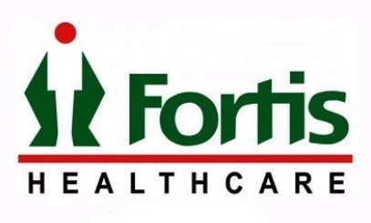



**Popularity:** Fortis Healthcare Limited, a part of the IHH Healthcare Berhad group, is one of the largest and most recognized healthcare service providers in India. Operating **28 healthcare facilities** **across 9 cities and 8 states**, with over 4,500 operational beds and **400 diagnostic centers** across India, the UAE, Nepal, and Sri Lanka, Fortis Healthcare has established a significant presence in the healthcare sector. Its extensive network and commitment to high-quality patient care have made it a trusted name among patients and medical professionals alike. Fortis boasts some of the best medical technologies and machinery, achieving high success rates in major organ transplants. The hospital chain is accredited by NABH (National Accreditation Board for Hospitals & Healthcare Providers) and JCI (Joint Commission International), globally recognized certifications that reflect Fortis’ adherence to the highest standards in healthcare.

**Impact:** Fortis Healthcare has profoundly shaped the healthcare landscape in India by providing a comprehensive range of medical services, from primary to quaternary care, including specialized treatments in oncology, orthopedics, cardiac care, and renal sciences. The company’s focus on clinical excellence and patient-centric care has set new benchmarks in the industry, driving advancements in medical technology and healthcare delivery. Fortis' diagnostic arm, **Agilus, is the largest diagnostic services provider in India**, further amplifying its contribution to the healthcare sector. Fortis is also at the forefront of technological integration in healthcare, including **AI-powered applications like the ADAYU app**, extensive t**elemedicine services**, and **remote consultation camps**. Additionally, the company is committed to sustainability through its **Green Hospitals Initiative**, with facilities in Mohali and Gurgaon implementing solar panels to generate a portion of their electricity, reducing their carbon footprint.

Fortis Healthcare also plays a crucial role in medical research, education, and training, helping to advance the overall healthcare system in India.

Fortis is also at the forefront of technological integration in healthcare. The company has pioneered the use of robotic-assisted surgeries, which offer higher precision, reduced recovery times, and minimally invasive options for patients. Beyond surgeries, Fortis is leveraging robotics in non-surgical treatments as well, improving the accuracy and effectiveness of various procedures

**Relevance:** In an era where healthcare demands are rapidly increasing, Fortis Healthcare's commitment to expanding its infrastructure and services is highly relevant. The company plans to increase its bed capacity from 4,500 to 10,000 over the next five to seven years, positioning itself to meet the growing healthcare needs of the population. Fortis is also a key player in the modern healthcare ecosystem, integrating advanced medical technologies and emphasizing personalized patient care. The company is contributing to modern societies by introducing AI robots for consultations and surgeries, leveraging data science for early disease detection, improved diagnosis, personalized treatments, enhanced hospital efficiency, and cost-effective care.

Fortis Healthcare's ongoing expansion includes a ₹13 billion investment (approximately $156 million) to enhance existing facilities and add around 2,200 new beds across various hospitals over the next three years. Key aspects of the expansion include:

* **Faridabad:** Utilizing available space to add new facilities.
* **Anandpur Sahib:** Operationalizing a newly acquired facility, adding 150 beds in phases.
* **Shalimar Bagh:** Planning a new tower with over 200 beds on an adjacent plot.
* **Manesar:** Beginning operations with 100 beds by Q2 of this financial year.

Fortis aligns its operations with national healthcare goals, such as the Ayushman Bharat scheme, which aims to provide affordable healthcare to millions of Indians. By participating in government programs and expanding its reach through international patient medical tourism and collaborations with more healthcare policy providers, Fortis remains a relevant and influential partner in India’s journey toward universal healthcare.

### **2. Core Features and Functionalities**

**Question:** Research and list the core features and functionalities of the selected platform. Describe how these features contribute to the platform’s success and user engagement.

**Answer:** Core Features and Functionalities of Fortis Healthcare:

1. **Comprehensive Medical Services:**Fortis offers a wide range of healthcare services, from preventive care to complex surgeries, including robotic-assisted surgeries and non-surgical treatments. This diversity attracts a broad patient base, contributing significantly to its success.
2. **State-of-the-Art Facilities:**Fortis hospitals are equipped with cutting-edge medical technology, enabling advanced procedures like robotic surgeries, liver transplants, and non-invasive treatments. These technologies improve patient outcomes, satisfaction, and trust in the healthcare system.
3. **Specialized Departments:**Fortis has specialized departments in oncology, orthopedics, cardiology, and nephrology, making it a preferred choice for patients seeking expert care in these fields. The focus on specialization drives higher patient engagement and loyalty.
4. **Advanced Diagnostics:**Through its diagnostics arm, Agilus, Fortis provides comprehensive diagnostic services that ensure accurate and timely diagnosis, which is crucial for effective treatment planning. The integration of advanced diagnostic tools supports patient outcomes and strengthens the healthcare process.
5. **Patient-Centric Care:**Fortis places a strong emphasis on personalized patient care, from the initial consultation to post-treatment follow-ups. This focus on patient satisfaction fosters loyalty and encourages repeat visits. Cooperative doctors and supportive staff are available at every stage of treatment, enhancing the overall experience.
6. **24/7 Emergency Services:**Fortis offers round-the-clock emergency care, catering to patients' needs at any time. This accessibility is a critical factor in patient trust and engagement, ensuring that patients can receive immediate care during emergencies.
7. **AI-Powered Chatbots and Virtual Assistants:**Fortis utilizes AI-driven chatbots on their patient portals to handle patient queries, schedule appointments, and provide information about treatments. This technology enhances patient engagement, reduces administrative workload, and ensures seamless communication.
8. **Digital Health Services:**Fortis offers digital health services, including online consultations, telemedicine, and electronic health records (EHR). These services increase accessibility, especially for patients in remote areas, and contribute to the platform's success by making healthcare more convenient and efficient.
9. **International Patient Services:**Fortis provides dedicated services for international patients, including visa assistance, travel arrangements, and personalized care plans. This feature enhances Fortis’s global appeal, attracting patients from around the world and contributing to its reputation as a trusted healthcare provider.
10. **Adayu Program:**Fortis Healthcare’s Adayu program integrates traditional Ayurvedic practices with modern healthcare. This initiative offers patients a holistic approach to health, combining ancient wisdom with contemporary medical practices, which appeals to a growing interest in complementary medicine.
11. **Robotic-Assisted Surgeries:**Fortis offers advanced robotic-assisted surgeries, where surgeons use robotic arms controlled through a console. These surgeries provide better control, precision, and outcomes, especially in minimally invasive procedures, further establishing Fortis as a leader in medical innovation.

**Contribution to Success and User Engagement:**

* **Comprehensive Services:** The broad range of services ensures patients can receive all necessary treatments under one roof, enhancing convenience and patient retention.
* **Technological Excellence:** The use of advanced medical technologies not only improves clinical outcomes but also attracts patients seeking the best possible care, such as robotic surgeries.
* **Specialization:** Specialized departments draw patients needing expert care, driving higher engagement and loyalty.
* **Personalized Care:** The patient-centric approach ensures that each patient feels valued and cared for, which is key to building long-term relationships with patients.
* **Accessibility:** 24/7 emergency services and the availability of advanced diagnostics improve accessibility, ensuring that patients can receive timely care when they need it most.

### **3. Real-World Problems**

**Question:** Identify the real-world problems that the platform aims to solve. Discuss how the platform addresses these problems through its features and functionalities.

**Answer:** Real-World Problems Addressed by Fortis Healthcare:

1. **Access to Quality Healthcare:**
   * **Problem:** In many regions, access to high-quality healthcare is limited, leading to poor health outcomes.
   * **Solution:** Fortis addresses this by establishing healthcare facilities across various regions, including underserved areas, and offering a full range of medical services to ensure that patients have access to the care they need. Teleconsultation services further enhance access.
2. **Advanced Medical Treatment:**
   * **Problem:** Patients often have to travel long distances to receive specialized treatments, leading to delays in care.
   * **Solution:** Fortis's specialized departments and state-of-the-art facilities provide advanced medical treatments locally, reducing the need for patients to seek care far from home.
3. **Accurate Diagnosis and Treatment:**
   * **Problem:** Misdiagnosis and delayed diagnosis can lead to ineffective treatment and worsen patient outcomes.
   * **Solution:** Fortis’s advanced diagnostic services, through Agilus, ensure accurate and timely diagnosis, which is critical for effective treatment planning and improved health outcomes.
4. **Patient Experience and Satisfaction:**
   * **Problem:** Healthcare experiences can often be stressful and impersonal, leading to dissatisfaction.
   * **Solution:** Fortis’s patient-centric approach, focusing on personalized care and support throughout the patient journey, enhances the overall patient experience and satisfaction.
5. **Emergency Care Availability:**
   * **Problem:** In emergencies, access to immediate medical care is crucial for saving lives, yet not always available.
   * **Solution:** Fortis’s 24/7 emergency services ensure that patients can receive immediate care when needed, which is vital for improving survival rates and patient trust. Collaboration with ambulance services ensures faster emergency response.
6. **Continuous Medical Education:**
   * **Problem:** Continuous medical education is essential to keep healthcare professionals updated with the latest advancements.
   * **Solution:** Fortis Institute of Medical Sciences provides ongoing training and education for healthcare professionals, ensuring they stay current with medical innovations and best practices.
7. **Patient Education and Engagement:**
   * **Problem:** A lack of awareness and education about health issues can lead to poor health outcomes.
   * **Solution:** Fortis offers preventive health programs and educational resources to empower patients with the knowledge they need to manage their health effectively. These initiatives encourage proactive health management and increase patient engagement.
8. **International Patient Services:**
   * **Problem:** International patients often face challenges related to travel, accommodation, and understanding the local healthcare system.
   * **Solution:** Fortis’s International Patients Team provides comprehensive support, including visa assistance, travel arrangements, and personalized care plans, ensuring a hassle-free medical journey.
9. **Inefficient Hospital Operations:**
   * **Problem:** Inefficiencies in hospital operations can lead to resource wastage, staff burnout, and suboptimal patient care.
   * **Solution:** Fortis uses data science and machine learning to optimize resource management and staff scheduling, improving operational efficiency and ensuring better patient care.

**How Fortis Healthcare Addresses These Problems:**

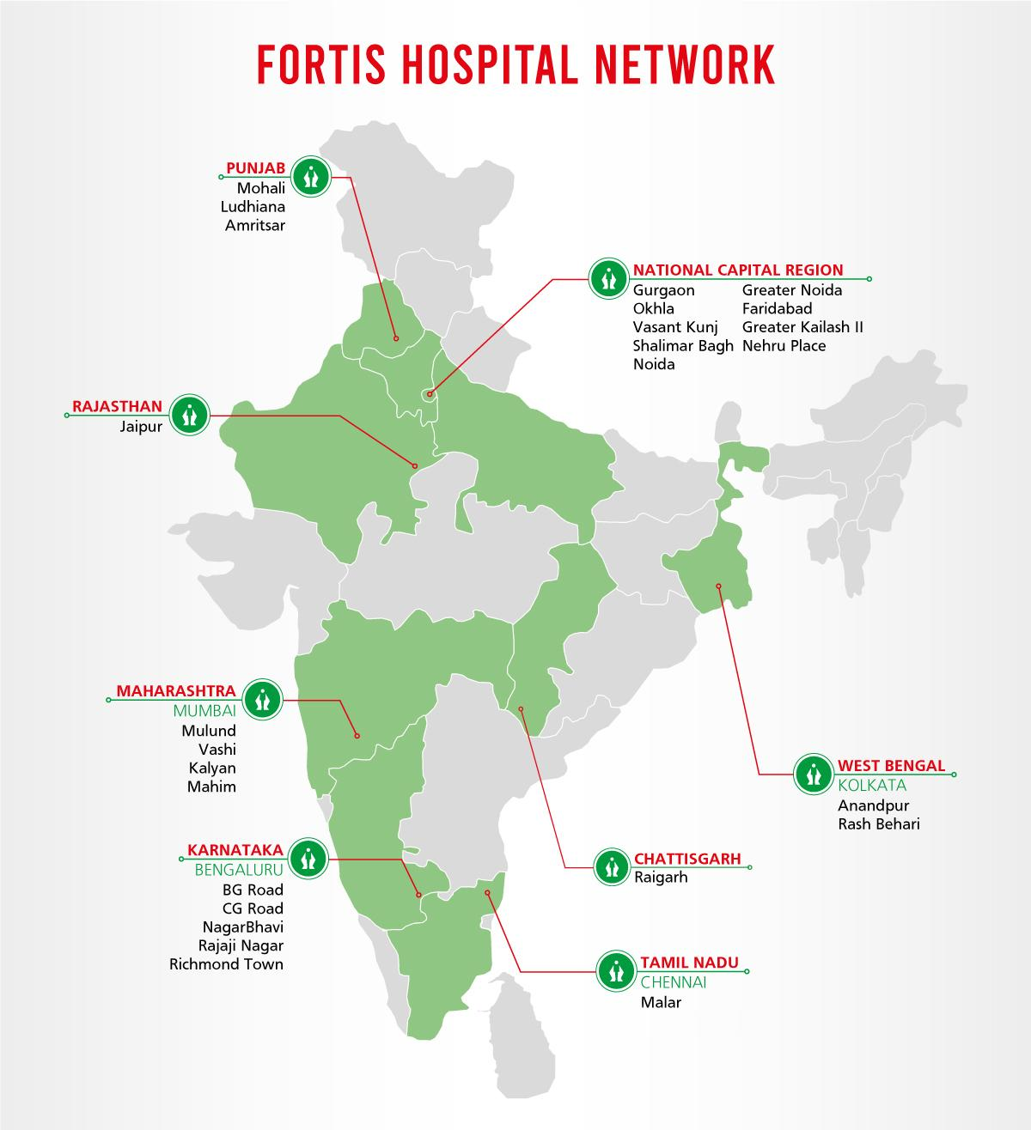

1. **Expansion of Facilities**: Fortis is continually expanding its network of hospitals and diagnostics centers, ensuring improved access to quality healthcare across multiple regions. This expansion is critical for reaching underserved areas, offering a wide range of medical services to meet the diverse healthcare needs of the population.
2. **Specialized Care**: By providing specialized treatments locally, Fortis reduces the burden on patients who might otherwise need to travel long distances for advanced medical care. The availability of specialized departments in oncology, orthopedics, cardiology, and nephrology ensures that patients receive expert care in their local region. Fortis also collaborates with more than 25 international healthcare policy providers and numerous national policy providers, facilitating cashless services and enhancing patient convenience.
3. **Advanced Diagnostics and Robotic Surgery**: Fortis integrates advanced diagnostic services and cutting-edge medical technologies, such as robotic-assisted surgeries. These innovations support accurate diagnosis, enable minimally invasive procedures, and improve patient outcomes. The use of robotic systems in surgeries, particularly in complex and delicate operations, allows for greater precision, reduced recovery times, and better overall patient care.
4. **Personalized Care**: Fortis emphasizes patient-centric care, which focuses on providing personalized treatment plans and comprehensive support throughout the patient journey. This approach not only improves patient satisfaction but also fosters trust and long-term relationships with the healthcare provider.
5. **Timely Medical Intervention**: Fortis ensures that patients have access to life-saving treatments whenever needed by providing 24/7 emergency services and advanced diagnostic tools. The immediate availability of these services is crucial for improving survival rates and enhancing patient trust. This includes a partnership with s**tartup RED** to provide ambulances within 10-30 minutes, ensuring that patients have access to life-saving treatments whenever needed.
6. **Efficient Hospital Operations**: Inefficiencies in hospital operations can lead to resource wastage, staff burnout, and suboptimal patient care. To address this, Fortis employs data science and machine learning to optimize resource management and staff scheduling. For example, at Fortis Hospital in Mumbai, predictive analytics are used to forecast patient admissions and adjust staffing levels, thereby improving operational efficiency and ensuring that patients receive timely care.

**Database Management & Schema Design**

### **4. Schema Design**

**Question:** Based on the features and functionalities you have identified, design a schema that reflects the platform’s data structure. Define the key entities, attributes, and relationships that underpin these features

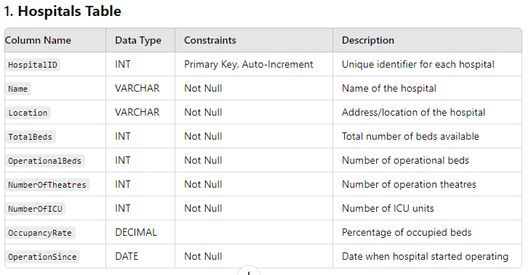

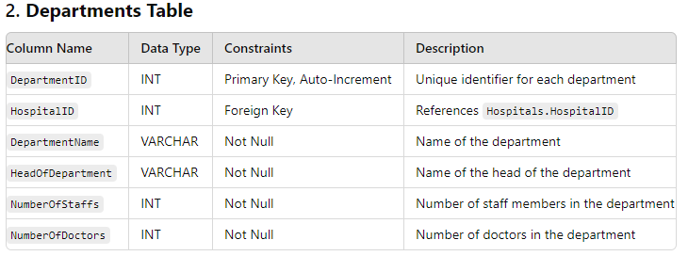

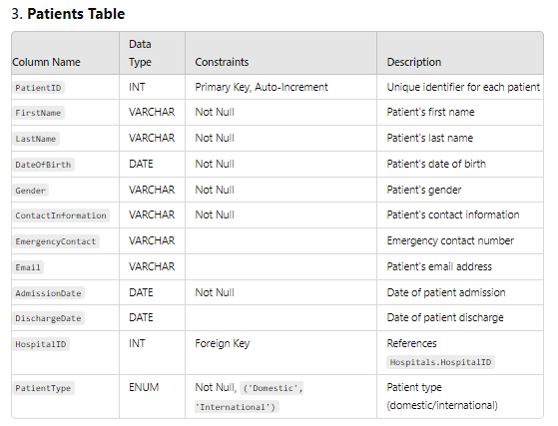

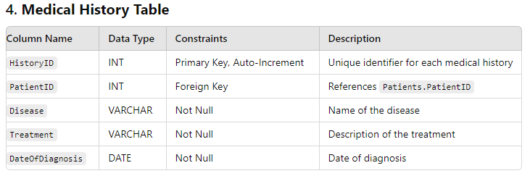

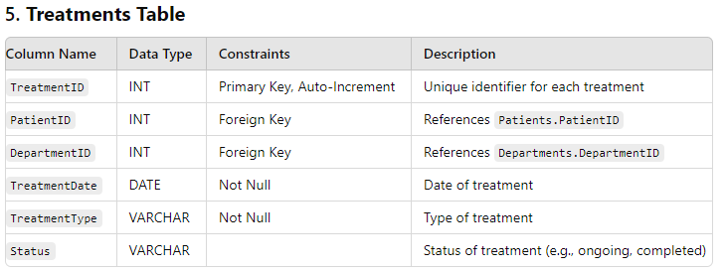

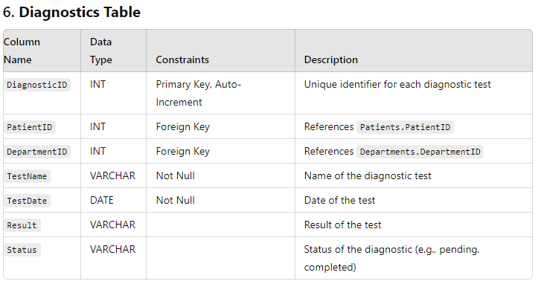

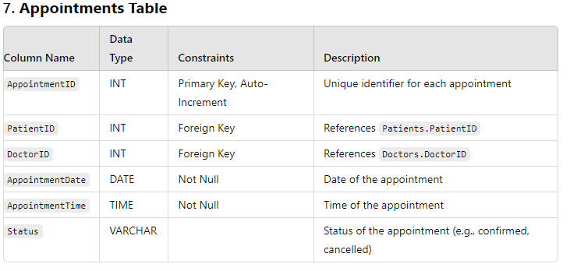

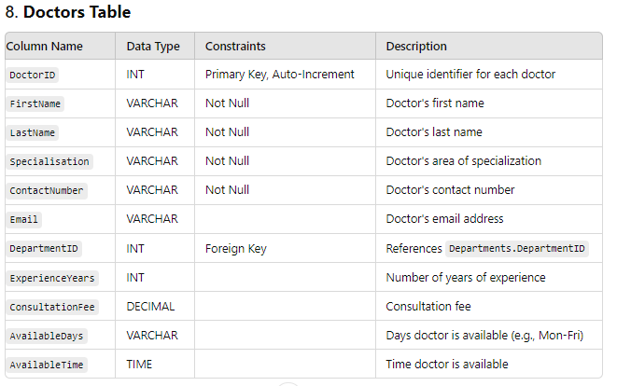

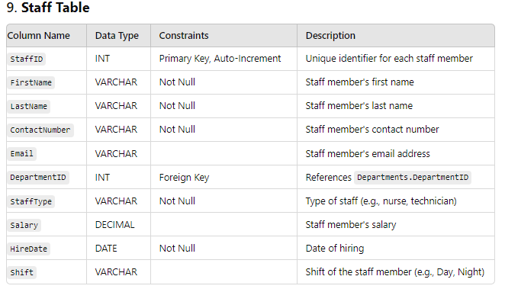

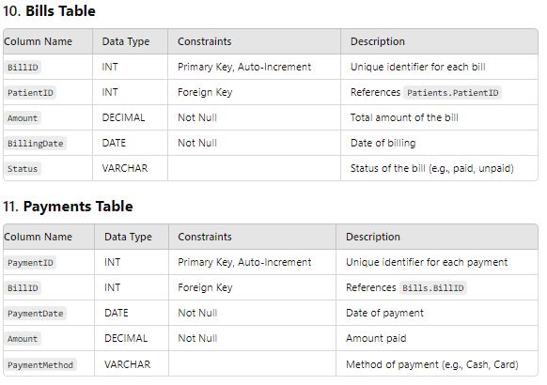

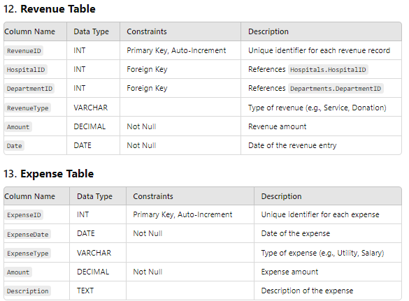

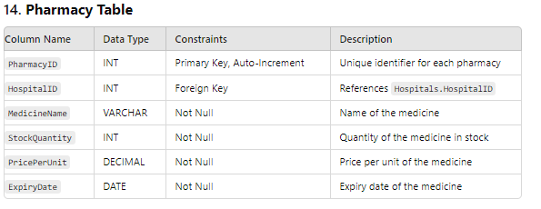

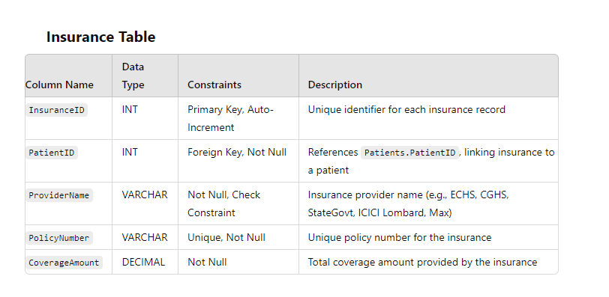

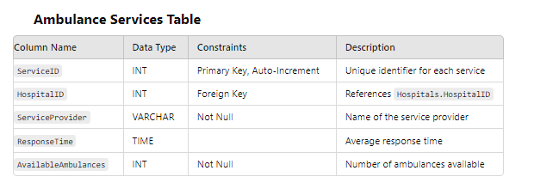

Here’s an overview of the **relationships between the tables** in the hospital management system, along with the type of each relationship:

### **1. Hospitals Table**

* **Primary Key**: HospitalID
* **Relationships**:
  + **Departments**: One-to-Many (A hospital can have multiple departments)
  + **Patients**: One-to-Many (A hospital can have multiple patients)
  + **Revenue**: One-to-Many (A hospital can generate multiple revenue records)
  + **Pharmacy**: One-to-Many (A hospital can have multiple pharmacies)
  + **Ambulance Services**: One-to-Many (A hospital can have multiple ambulance services)

### **2. Departments Table**

* **Primary Key**: DepartmentID
* **Foreign Key**: HospitalID (References Hospitals.HospitalID)
* **Relationships**:
  + **Doctors**: One-to-Many (A department can have multiple doctors)
  + **Patients**: Many-to-Many (A patient can be treated in multiple departments, and a department can treat multiple patients) - Managed through the **Treatments** table.
  + **Treatments**: One-to-Many (A department can have multiple treatments)
  + **Diagnostics**: One-to-Many (A department can have multiple diagnostic tests)
  + **Revenue**: One-to-Many (A department can generate multiple revenue records)
  + **Staff**: One-to-Many (A department can have multiple staff members)

### **3. Patients Table**

* **Primary Key**: PatientID
* **Foreign Key**: HospitalID (References Hospitals.HospitalID)
* **Relationships**:
  + **Medical History**: One-to-Many (A patient can have multiple medical history records)
  + **Treatments**: One-to-Many (A patient can have multiple treatments)
  + **Diagnostics**: One-to-Many (A patient can undergo multiple diagnostic tests)
  + **Appointments**: One-to-Many (A patient can have multiple appointments)
  + **Bills**: One-to-Many (A patient can have multiple bills)
  + **Ambulance Services**: Many-to-One (Many patients can use ambulance services, each linked to a hospital)

### **4. Medical History Table**

* **Primary Key**: HistoryID
* **Foreign Key**: PatientID (References Patients.PatientID)
* **Relationships**:
  + No direct relationships with other tables.

### **5. Treatments Table**

* **Primary Key**: TreatmentID
* **Foreign Keys**:
  + PatientID (References Patients.PatientID)
  + DepartmentID (References Departments.DepartmentID)
* **Relationships**:
  + No direct relationships with other tables but connects **Patients** and **Departments**.

### **6. Diagnostics Table**

* **Primary Key**: DiagnosticID
* **Foreign Keys**:
  + PatientID (References Patients.PatientID)
  + DepartmentID (References Departments.DepartmentID)
* **Relationships**:
  + No direct relationships with other tables but connects **Patients** and **Departments**.

### **7. Appointments Table**

* **Primary Key**: AppointmentID
* **Foreign Keys**:
  + PatientID (References Patients.PatientID)
  + DoctorID (References Doctors.DoctorID)
* **Relationships**:
  + No direct relationships with other tables but connects **Patients** and **Doctors**.

### **8. Doctors Table**

* **Primary Key**: DoctorID
* **Foreign Key**: DepartmentID (References Departments.DepartmentID)
* **Relationships**:
  + **Appointments**: One-to-Many (A doctor can have multiple appointments)

### **9. Staff Table**

* **Primary Key**: StaffID
* **Foreign Key**: DepartmentID (References Departments.DepartmentID)
* **Relationships**:
  + No direct relationships with other tables.

### **10. Bills Table**

* **Primary Key**: BillID
* **Foreign Key**: PatientID (References Patients.PatientID)
* **Relationships**:
  + **Payments**: One-to-Many (A bill can have multiple payments)

### **11. Payments Table**

* **Primary Key**: PaymentID
* **Foreign Key**: BillID (References Bills.BillID)
* **Relationships**:
  + No direct relationships with other tables.

### **12. Revenue Table**

* **Primary Key**: RevenueID
* **Foreign Keys**:
  + HospitalID (References Hospitals.HospitalID)
  + DepartmentID (References Departments.DepartmentID)
* **Relationships**:
  + No direct relationships with other tables.

### **13. Expense Table**

* **Primary Key**: ExpenseID
* **Relationships**:
  + No direct relationships with other tables.

### **14. Pharmacy Table**

* **Primary Key**: PharmacyID
* **Foreign Key**: HospitalID (References Hospitals.HospitalID)
* **Relationships**:
  + **Suppliers**: Many-to-Many (A pharmacy can have multiple suppliers, and a supplier can supply to multiple pharmacies)

### **15. Insurance Table**

* **Primary Key**: InsuranceID
  + A unique identifier for each insurance record. This ensures that each insurance policy can be individually referenced.
* **Foreign Key**: PatientID (References Patients.PatientID)
  + This establishes a link between the **Insurance** table and the **Patients** table. Each insurance record is associated with a specific patient.
* **Relationships**:
  + **One-to-Many**:
    - **Patients** to **Insurance**: A single patient can have multiple insurance policies, creating a One-to-Many relationship between Patients and Insurance.

### **16. Ambulance Services Table**

* **Primary Key**: ServiceID
* **Foreign Key**: HospitalID (References Hospitals.HospitalID)
* **Relationships**:No direct relationships with other tables.

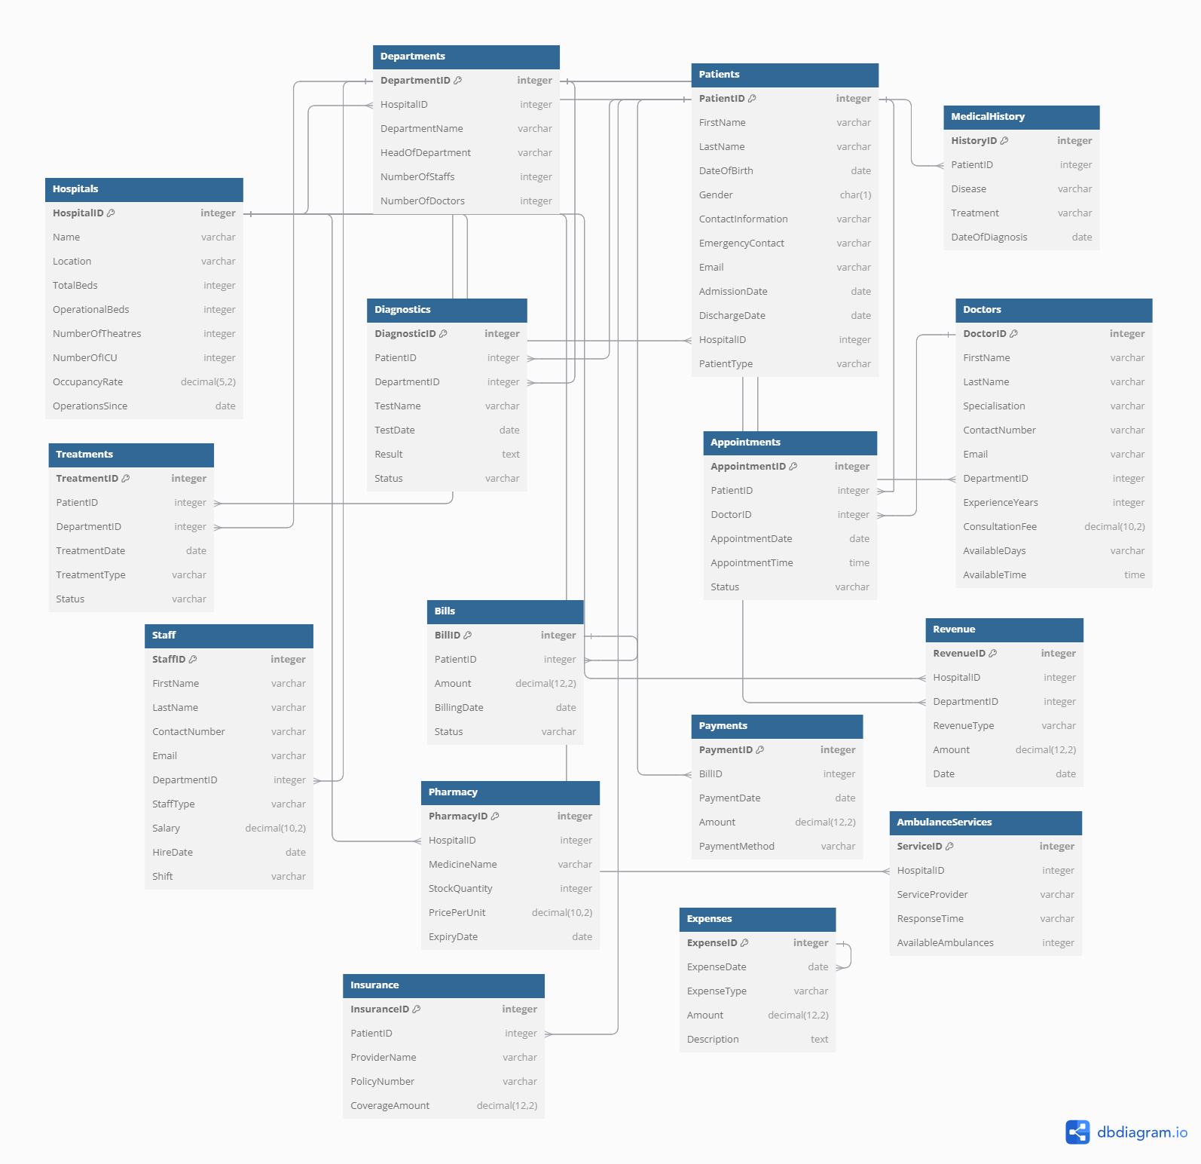

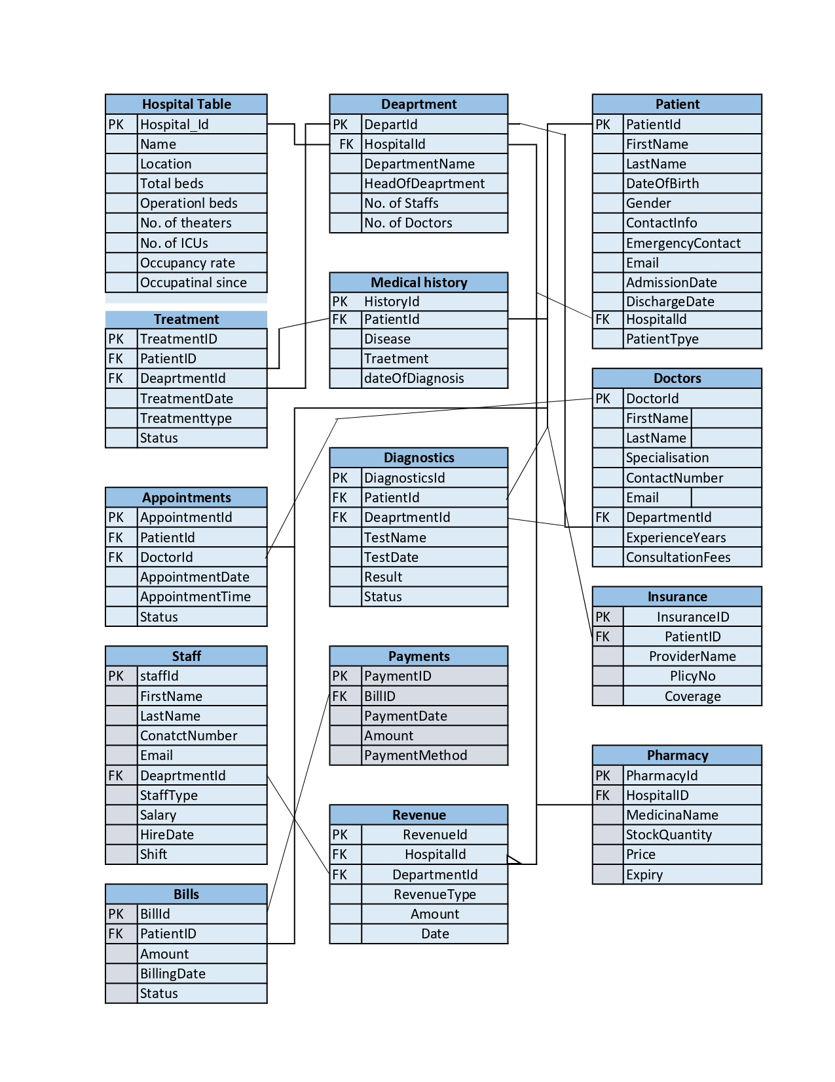

**Revenue and Profit Growth Strategies**

**Question:** After completing the product dissection and schema design steps for the chosen platform, conduct a comprehensive case study on the above chosen industry. Your goal is to identify and propose strategies to increase the **profit of the industry by at least 25%**.

Create a detailed report summarizing your findings and proposals. Include data-driven justifications for each proposed strategy and present your case study using visual aids such as charts, graphs, and diagrams to illustrate your points. Outline the steps, resources, and timeline required to achieve the desired revenue and profit growth.

**Focus on the following aspects:**

To solve scenario-based questions such as increasing Instamart's profit by 25%, data science students should adopt an **inside-out** methodology. This approach involves analyzing internal factors first—examining company expenses, customer behavior, and revenue strategies—to drive profitability.

### **I. Analyzing Fortis Hospital's Current Status**

| **Category** | **Details** |
| --- | --- |
| **Current Financial Data** | **Collect Financial Data** |
| **Revenue**: Gather data from various revenue streams, such as patient services (inpatient and outpatient), diagnostics, pharmacy sales, surgical procedures, and insurance reimbursements. |
| **Expenses**: Collect data on all operational costs, including medical supplies, salaries of medical and administrative staff, technology investments, facility maintenance, and marketing expenses. |
| **Analyze Current Profit** |
| **Profit Calculation**: Calculate the current profit by subtracting total expenses from total revenue. |
| **Profit Trends:** Analyze profit trends over the past few quarters or years to identify growth patterns or potential declines. |
| **Sources of Revenue** | **Identify Revenue Streams** |
| **Patient Services:** Income from inpatient and outpatient care, surgeries, and other medical procedures. |
| **Diagnostics:** Revenue from laboratory tests, imaging services (like MRI, CT scans), and other diagnostics. |
| **Pharmacy Sales:** Income from selling medicines and medical supplies to patients. |
| **Insurance and Government Programs:** Revenue from insurance reimbursements and government healthcare schemes. |
| **Analyze Revenue Contribution** |
| **Segmentation:** Break down the revenue by each stream to understand the contribution of each segment. |
| **Top Departments/Services:** Identify the top-earning departments and most popular services. |
| **Sources of Expenses** | **Identify Major Expenses** |
| **Medical Supplies:** Costs related to the procurement of medicines, surgical tools, and other supplies. |
| **Salaries:** Payments to doctors, nurses, administrative staff, and other hospital employees. |
| **Technology:** Investments in medical equipment, IT systems, and software. |
| **Facility Maintenance:** Costs associated with maintaining the hospital infrastructure, including utilities and cleaning.    **Marketing and Patient Acquisition:** Expenses incurred in promoting hospital services and acquiring new patients. |
| **Analyze Expense Distribution** |
| **Segmentation:** Break down expenses by category to understand where the majority of the money is being spent. |
| **Cost Efficiency:** Identify areas where costs can be reduced without compromising quality or patient care. |
| **Customer Acquisition & Retention** | **Analyse Customer Acquisition Channels** |
| **Channels**: Identify where new patients are coming from, such as referrals, online searches, insurance networks, or marketing campaigns. |
| **Effectiveness**: Evaluate the effectiveness of each channel by comparing acquisition costs and the number of patients acquired. |
| **Understand Customer Behaviour and Retention** |
| **Patient Data:** Analyse data on patient visits, treatment outcomes, feedback, and follow-up rates |
| **Churn Analysis:** Identify reasons why patients may choose not to return and develop strategies to reduce churn. |
| **Retention Rates:** Calculate retention rates and identify factors that contribute to patient loyalty. |

### **II. Focus Areas for Increasing Fortis Hospital's Profit by 25%**

To achieve a 25% increase in profit, Fortis Hospital must focus on several key areas, including internal management, patient care, market expansion, post-treatment management, and branding. Below is a breakdown of these areas and proposed measures:

| **Category** | **Focus Area** | **Measures** |
| --- | --- | --- |
| **Internal Management**  **~ 8%** | **Operational Efficiency**  **~ 6.5%** | **Waste Management:** Optimize inventory management using data analytics to reduce waste in medical supplies and improve procurement. |
| **Automate Processes:** Invest in AI and machine learning tools to automate tasks such as patient billing, appointment scheduling, and inventory updates. |
| **Cost Control:** Conduct regular audits of medical equipment, software, and service agreements. Negotiate better terms and seek cost-effective alternatives without compromising quality.  **Energy Efficiency**: Invest in energy-efficient infrastructure or practices to reduce utility costs, such as LED lighting, solar panels, or efficient HVAC systems. |
| **Employee Productivity**  **~ 1.5 %** | **Training Programs:** Develop continuous training programs focused on medical excellence, patient care, and administrative efficiency. |
| **Performance Metrics:** Implement a robust performance tracking system with clear metrics and reward systems to motivate staff and improve productivity. |
| **Patient Care Strategy (~4% Profit Increase)** | **Enhance Service Offerings (~2%)** | **Specialty Services:** Expand high-margin specialty services like oncology, orthopedics, and cardiac care.  **Telemedicine:** Increase telemedicine offerings to reach patients who prefer remote consultations, thereby increasing patient volume.  **Wellness Programs**: Offer preventive health services and wellness programs, such as regular health check-ups, fitness classes, and nutrition counseling. This can attract patients focused on maintaining health rather than just treating illness. |
|  | **Improve Patient Outcomes (~2%)** | **Quality of Care:** Invest in state-of-the-art medical equipment and continuously train medical staff to improve patient outcomes.  **Preventive Care Programs:** Launch preventive care programs to reduce the incidence of chronic diseases, which can also serve as a new revenue stream. |
| **Market Expansion (~4% Profit Increase)** | **Geographic Expansion (~2%)** | **New Facilities:** Open new healthcare facilities in high-demand areas, both domestically and internationally. |
| **Partnerships:** Form strategic partnerships with local healthcare providers to expand the hospital’s reach. |
| **Market Penetration (~2%)** | **Enhanced Outreach:** Strengthen market presence in existing locations by improving service offerings, expanding the range of treatments, and enhancing the overall patient experience. |
| **Targeted Marketing:** Implement targeted marketing strategies to attract specific patient demographics, such as international patients for medical tourism |
| **Post-Treatment Management (~2% Profit Increase)** | **Patient Follow-Up (~1%)** | **Personalized Follow-Ups:** Use data analytics to send personalized follow-up emails, reminders for check-ups, and health tips to improve patient retention. |
| **Loyalty Programs:** Develop loyalty programs that reward patients for regular visits, follow-ups, and referrals. |
| **Enhanced Support (~1%)** | **Patient Feedback:** Implement a robust system for collecting and analysing patient feedback to continuously improve services.  **Post-Treatment Care:** Offer post-treatment care services, such as home visits or virtual check-ups, to enhance patient recovery and satisfaction. |
| **Branding and Marketing (~6% Profit Increase)** | **Brand Awareness (~1.5%)** | **Digital Marketing:** Increase investment in digital marketing campaigns, including social media, content marketing, and influencer partnerships. |
| **SEO and SEM:** Optimize the hospital’s website for search engines and invest in search engine marketing to drive more traffic. |
| **Word of Mouth and Referrals (~2.5%)** | **Referral Programs**: Create and promote referral programs that incentivize existing patients to bring in new patients through rewards and discounts. |
| **Positive Reviews:** Encourage satisfied patients to leave positive reviews on social media and healthcare review platforms**.** |
| **Community Engagement**  **~ 1%** | **Local Events and Sponsorships:** Participate in and sponsor local events and community activities to build a strong brand presence and connect with the community. |
|  | **Acquisition Channels**  **~ 1 %** | **Digital Advertising:** Invest in targeted digital advertising campaigns to attract new customers.  **Partnerships and Affiliates:** Form strategic partnerships and affiliate programs with insurance companies, corporate wellness programs, and other organizations to expand reach. |

### **III. Defining Strategies and Execution Plan**

| **Category** | **Details** |
| --- | --- |
| **Optimize Expenses** | **Cost Reduction**: Implement measures to reduce operational costs, such as negotiating better terms with suppliers, streamlining logistics, and adopting cost-effective technologies. |
| **Efficiency Improvements**: Use data analytics to optimize inventory management and reduce waste. |
| **Enhance Revenue Streams** | **New Services:** Introduce new services such as premium health packages, wellness programs, and advanced diagnostic services. |
| **Pricing Strategies:** Implement dynamic pricing strategies for elective procedures and specialty services to maximize revenue. |
| **Timeline and Resources** | **Phase 1 (0-6 months):** Focus on operational efficiency improvements, waste reduction, and initial marketing campaigns. |
| **Phase 2 (6-12 months):** Expand service offerings, enhance patient care strategies, and begin market expansion efforts. |
| **Phase 3 (12-18 months):** Execute on post-treatment management strategies, build brand awareness, and strengthen community engagement. |
| **Improve Patient Acquisition and Retention** | **Targeted Marketing:** Use data-driven insights to target specific patient demographics and geographic areas. |
| **Retention Programs:** Develop programs focused on patient satisfaction and loyalty, including personalized follow-ups and health monitoring services. |

**Conclusion**

By focusing on internal management, patient care strategy, market expansion, post-treatment management, and branding, Fortis Hospital can strategically enhance its profitability by 25%. Each focus area should be approached with data-driven insights to ensure that initiatives are effective and aligned with patient needs and market demands. Implementing these strategies will not only increase profitability but also strengthen Fortis Hospital’s position as a leading healthcare provider.